|  |
| --- |
|  |
| Technical design |
| *Fasten your seatbelts* |
|  |

ITopiaLogo

*Datum: 22-10-2014*

*Klas: IN-102 team 3  
Versie: 0.2*

*Naam stud: Sjors de Haan // Stud.nr: 500706376*

*Naam stud: Ward v/d Meulen // Stud.nr: 500669712*

*Naam stud: Jasper Nota // Stud.nr: 500700743*

*Naam stud: Talitha Wingelaar // Stud.nr: 500617878*

*Naam stud: Jony Zeitoun // Stud.nr: 500709002*

Contents

Introduction 3

Revisions 4

Project specifications 5

Devices 5

Placement 5

Captive portal 6

Database 7

Usage 7

Servers & specs 7

Pros & cons 7

Final choice 7

Protocols 8

DHCP & DNS 9

# Introduction

In this document you will find all technical information regarding the installation of a wireless network inside a Corendon-owned Boeing 737-800. The following information will be discussed in this document:

* Raspberry pi specification
* Device quantity
* Access point location/placement
* SSID name

## Revisions

22-10-2014

* Added revisions table
* Changed database from physical objects to the configuration of the tomcat side
* Information added to device specifications table
* Subject “captive portal” added
* *To-do: change database from physical to digital (tomcat specifications)*

## Project specifications

### Devices

|  |  |
| --- | --- |
| Model | Raspberry pi B/B+ |
| Quantity | 4 B’s |
| OS | Raspbian Wheezy |
| Storage | Minimal 4GB |
| Wi-Fi receiver/transmitter | TP-LINK WL823N |
| Wi-Fi receiver/transmitter speed | 300Mbps |

### Placement

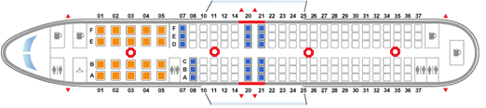

The devices shall be spread throughout the plane as to make sure that every location within the plane has a good connection for the entire flight. The wireless access point will be called ‘Corendon airlines’ and will start off with a captive portal.

|  |  |
| --- | --- |
| Wireless connection name (SSID) | Corendon_airlines |
| Amount of connection points through plane | 4 |

Captive portal  
  
In the picture below you will see an example of the captive portal.

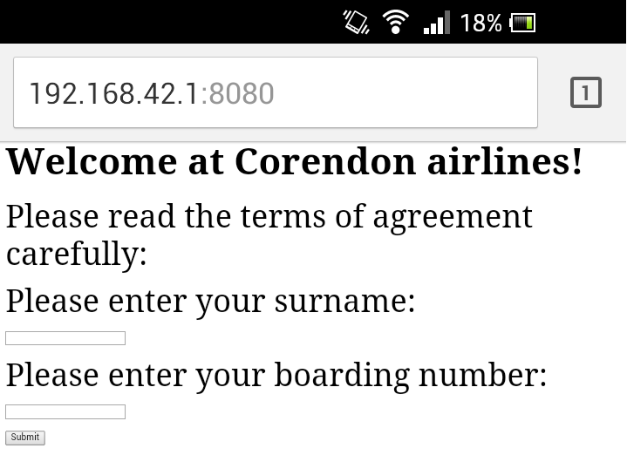  
(This is currently in development)  
The URL in the picture is set to ‘192.168.42.1:8080’, which is the default gateway.  
  
This is what the user sees when the connection with the access point is established.   
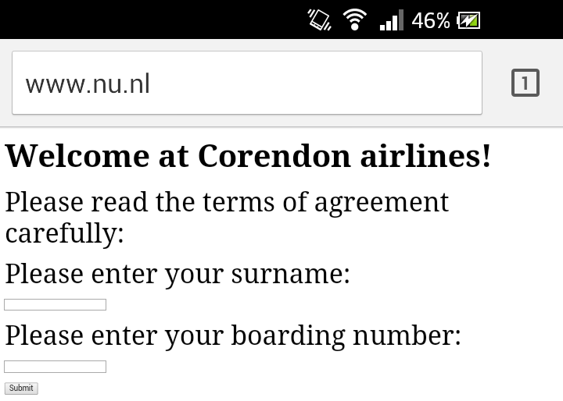  
(This is currently in development)  
As you can see in the picture above is that no matter which URL the users enters, he will be forwarded to the captive portal.  
  
  
The IP tables make an exception when the user clicks on the “Submit” button.  
Which allows the user to reach other websites.

## Database

In this chapter we’ll be describing the database. Subjects such as pricing, specifications, choice of server and usage will be touched upon.

### Usage

(What will the server be used for? What does it require to do?)

### Servers & specs

(Describe here multiple servers and their specs)

### Pros & cons

(Compare the chosen servers to each other to find the ‘best’)

### Final choice

(Which server has been chosen and will be used? Show price and reasoning)

## Protocols

|  |  |
| --- | --- |
|  |  |
|  |  |
|  |  |
|  |  |

## DHCP & DNS

|  |  |
| --- | --- |
|  |  |
| 192.168.42.2 t/m 192.168.42. 190 | For all passengers one. |